### **CHAPTER 1**

### **COMPANY PROFILE**

### **CHAPTER 2**

### **ABOUT THE DEPARTMENT**

### **CHAPTER 3**

### **TASKS PERFORMED**

**3.1 FRONTEND DEVELOPMENT**

* **HTML:** Hyper Text Markup Language forms the backbone of any web application, including those built with Spring Boot. It serves as the structural framework, defining the content and layout of a webpage. HTML consists of various elements such as headings, paragraphs, lists, images, tables, and forms, which help organize information in a meaningful way. It uses tags to mark different components of a webpage, ensuring they are properly displayed in browsers. In a Spring Boot application, HTML can be used with templating engines like Thymeleaf, which allows dynamic content rendering by embedding Java logic within the markup. This enables developers to create reusable and interactive web pages while integrating data from backend services efficiently.
* **CSS:** Cascading Style Sheets is responsible for styling and enhancing the visual appeal of a web application. It controls aspects such as colors, fonts, spacing, positioning, and responsiveness, ensuring an intuitive user experience across different devices. CSS can be written inline, within a tag in an HTML document, or externally in a separate stylesheet. Spring Boot applications often use CSS to style static HTML files or dynamically rendered pages. Additionally, modern CSS frameworks like Bootstrap or Tailwind CSS can be integrated to provide pre-designed components and utility classes, reducing development time while maintaining a professional and consistent design.
* **JavaScript:** Is a powerful scripting language that adds interactivity and dynamic behaviour to web applications. It enables functionalities such as user input validation, animations, event handling, and asynchronous communication with backend APIs. In a Spring Boot application, JavaScript can be used to interact with RESTful services, fetching data from the server and updating the webpage without requiring a full reload. This is commonly achieved using AJAX or modern frontend frameworks like React, Angular, or Vue.js, which enhance the application’s interactivity. JavaScript’s ability to manipulate the Document Object Model (DOM) allows developers to create smooth user experiences, making it an indispensable tool in modern web development.

**3.2 BACKEND DEVELOPMENT**

A backend Spring Boot application using Maven for web development provides a robust and scalable framework for building enterprise-grade applications. Spring Boot simplifies the development process by offering built-in configurations, auto-configuration, and dependency management, making it easier to create production-ready applications with minimal setup. Maven acts as the project management tool, handling dependencies, build lifecycle, and packaging. In a typical Spring Boot web application, Maven manages libraries such as Spring Web for handling HTTP requests, Spring Data for database interactions, and Thymeleaf or RESTful services for communication between frontend and backend. The Spring Boot framework includes an embedded Tomcat server, allowing developers to run the application without requiring additional deployment configurations. The application follows a layered architecture, where controllers process requests, services contain business logic, and repositories manage data persistence with JPA or Hibernate. With Maven’s dependency management, developers can easily integrate authentication, logging, and third-party APIs, streamlining the development process. Additionally, Spring Boot provides extensive support for RESTful APIs, enabling seamless interaction between the frontend and backend through JSON-based communication. By combining Spring Boot with Maven, developers can build secure, scalable, and efficient web applications that are well-suited for modern software development.

**3.3 DATABASE MANAGEMENT**

In a Spring Boot application, MySQL database management using XAMPP provides a flexible and efficient approach for handling data. XAMPP is a local server environment that includes MySQL, Apache, and PHPMyAdmin, making database administration and development more convenient. MySQL serves as the database system, storing structured data and enabling efficient retrieval and manipulation using SQL queries. Spring Boot integrates with MySQL seamlessly through JPA (Java Persistence API) and Hibernate, allowing developers to interact with the database using object-relational mapping (ORM). By configuring the application. properties or application.yml file, developers specify the database connection details, including the MySQL driver, username, password, and schema. The application can then define entity classes representing database tables and use Spring Data JPA repositories to perform CRUD (Create, Read, Update, Delete) operations effortlessly. With XAMPP, MySQL can be managed using PHPMyAdmin, providing a user-friendly graphical interface for handling tables, queries, and database users. Additionally, Spring Boot applications often use RESTful APIs to retrieve and store data dynamically, ensuring seamless interaction between the backend and frontend. By leveraging MySQL with XAMPP in Spring Boot, developers gain a robust and efficient way to manage data for web applications, enhancing performance, scalability, and usability.

### **CHAPTER 4**

### **REFLECTION NOTES**

**4.1 EXPERIENCE**

Developing a dynamic construction website using Spring Boot has been an insightful experience, highlighting the powerful capabilities of the framework in building scalable and efficient web applications. One of the key takeaways is the seamless integration of frontend technologies like HTML, CSS, and JavaScript with the Spring Boot backend, enabling interactive and responsive user experiences. The ability to leverage Spring Data JPA for managing construction project data in a MySQL database ensured efficient data retrieval. Implementing RESTful APIs facilitated real-time interactions between the user interface and backend services, making the website more dynamic and user-friendly. Additionally, using Thymeleaf as a templating engine enhanced the presentation layer by allowing dynamic content rendering based on user inputs and database records. The experience also emphasized the importance of handling authentication and security measures, such as using Spring Security to safeguard user credentials and role-based access control for different stakeholders like project managers and contractors. Another valuable aspect was configuring Maven for dependency management, streamlining the development process and ensuring efficient version control. Overall, working on a dynamic construction website with Spring Boot has reinforced the significance of structuring code effectively, optimizing database interactions, and implementing best practices for web application development, ultimately leading to a robust and scalable solution tailored to industry needs.

**4.2 TECHNICAL OUTCOMES**

**4.2.1 SYSTEM REQUIREMENT SPECIFICATION**

**4.2.2 HARDWARE REQUIREMENTS**

* Processor: Intel i5 or above (Quad-core recommended)
* Hard Disk: 100 GB (minimum)
* Memory (RAM): 8 GB (minimum), 16 GB recommended

**4.2.3 SOFTWARE REQUIREMENTS**

* Web Server: Embedded Apache Tomcat (included with Spring Boot)
* Operating System: Windows
* Platform: Java 17+, Spring Boot Framework
* Build Tool: Maven
* Frontend Technologies: HTML5, CSS3, JavaScript
* IDE (Editor): VS Code
* Database: MySQL / PostgreSQL / H2 (for development)
* JDK: Java Development Kit 17 or later

**4.3 SYSTEM ANALYSIS AND DESIGN**

**4.3.1 EXISTING SYSTEM**

In the development of a construction website using the Spring Boot framework, an existing system typically consists of a well-defined architecture that integrates frontend, backend, and database management efficiently. The backend, built using Spring Boot, provides RESTful APIs to manage various features such as project listings, service details, customer inquiries, and testimonials. It incorporates Spring Security for authentication and authorization, ensuring secure access to user data. The frontend is developed using HTML, CSS, and JavaScript, enhancing responsiveness and interactivity for users accessing construction project details. MySQL serves as the database management system, storing structured data related to ongoing and completed projects, service offerings, and client feedback. The system often includes an admin panel for construction firms to update project statuses, add new services, and manage customer interactions seamlessly. Spring Data JPA and Hibernate facilitate database interactions, allowing efficient CRUD operations without complex SQL queries. Additionally, Maven is used for dependency management, ensuring smooth integration of various Spring Boot modules and third-party libraries. The existing system may also leverage cloud deployment services to enhance scalability and reliability, ensuring seamless performance even with high user traffic. With these components working together, a construction website built on Spring Boot delivers a dynamic, secure, and efficient platform for managing construction projects while providing an intuitive user experience.

**4.3.2 DISADVANTAGES OF THE EXISTING SYSTEM**

1. **Performance concerns** – Inefficient database queries or excessive API calls can slow down response times, especially when handling large volumes of project data.
2. **Frontend-backend integration challenges** – Ensuring smooth real-time interactions between HTML, CSS, JavaScript, and Spring Boot APIs may require additional optimization techniques such as caching.
3. **Security risks** – Weak authentication and authorization implementations can expose sensitive user or project data to unauthorized access.
4. **Scalability and maintenance issues** – As the system expands, updating features or migrating to cloud environments requires strategic planning to prevent architectural bottlenecks.
5. **Manual database management limitations** – Using MySQL and PHPMyAdmin for managing large-scale project data may become inefficient over time, requiring advanced database management tools.
6. **Dependency conflicts with Maven** – Version incompatibilities in dependencies can lead to errors, requiring constant monitoring and troubleshooting.

**4.3.3 PROPOSED SYSTEM**

The proposed system for developing a dynamic construction website using the Spring Boot framework aims to enhance efficiency, scalability, and user experience while addressing the limitations of the existing system. The backend will leverage Spring Boot’s microservices architecture to improve modularity, allowing independent services for project management, service offerings, user authentication, and customer testimonials. RESTful APIs will be optimized for seamless communication between the frontend and backend, ensuring fast data retrieval and updates. The frontend will incorporate modern technologies such as React or Angular for a more dynamic and interactive user interface, providing real-time updates and enhanced user engagement. MySQL will remain the primary database management system, but will be integrated with caching mechanisms like Redis to improve data access speeds and reduce server load. Security will be reinforced using Spring Security with advanced authentication protocols, such as OAuth2, to protect user data and ensure role-based access control. The proposed system will also implement automated database backups and cloud deployment for high availability and reliability, ensuring smooth scaling as the business grows. Additionally, continuous integration and deployment will be set up using tools like Jenkins or GitHub Actions, enabling faster development cycles and reducing manual deployment efforts. By integrating these improvements, the proposed system will provide a more efficient, secure, and scalable platform tailored to the needs of a construction business, enabling seamless project management, customer interactions, and service listings.

**4.3.4 ADVANTAGES OF THE PROPOSED SYSTEM**

1. **Optimized RESTful APIs** – Streamlined communication between frontend and backend ensures faster response times and seamless data retrieval.
2. **Enhanced User Experience** – Integration of modern frontend frameworks like React or Angular provides interactive UI elements, real-time updates, and a visually appealing interface.
3. **Better Performance with Caching** – Using Redis or other caching mechanisms reduces database queries, improves load times, and optimizes system efficiency.
4. **Advanced Security Implementation** – Spring Security with OAuth2 authentication protects user data, ensures secure logins, and implements role-based access control.
5. **Automated Database Management** – Scheduled backups and cloud database solutions enhance reliability, prevent data loss, and support large-scale operations.
6. **Scalability for Future Growth** – The system can accommodate expanding user needs, additional features, and increased data volumes without performance bottlenecks.

**4.4 SYSTEM ARCHITECTURE**

**4.4.1 DATA FLOW DIAGRAM**

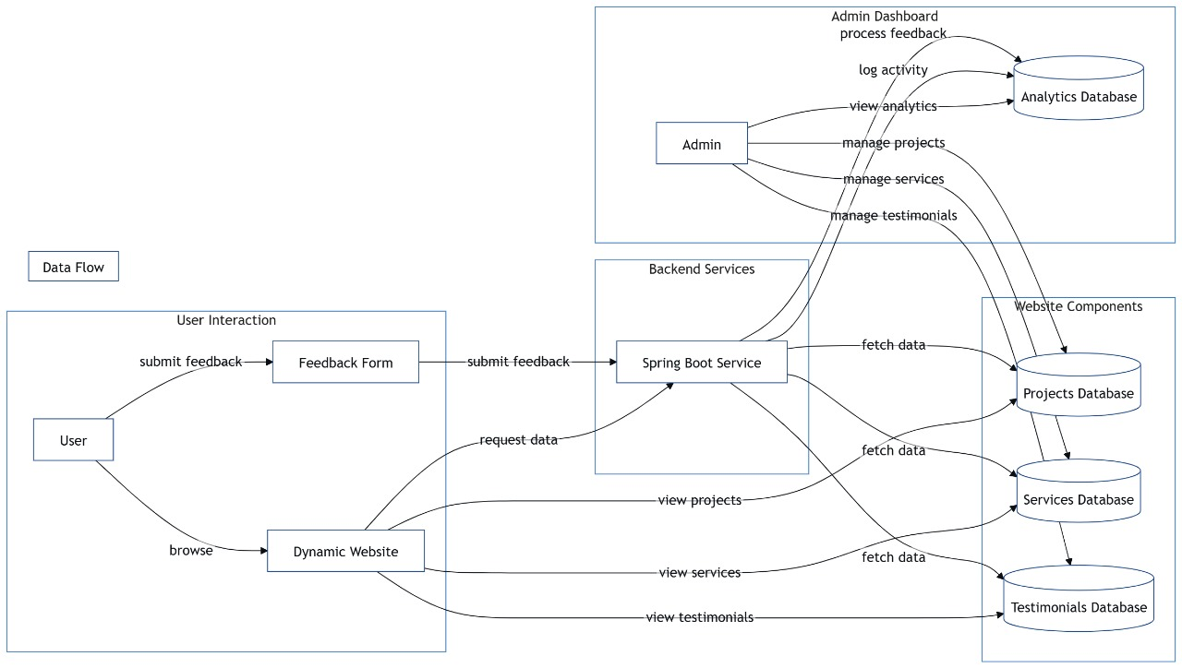

**Fig 4.4.1 Data Flow Diagram**

**4.4.2 UML DIAGRAM**

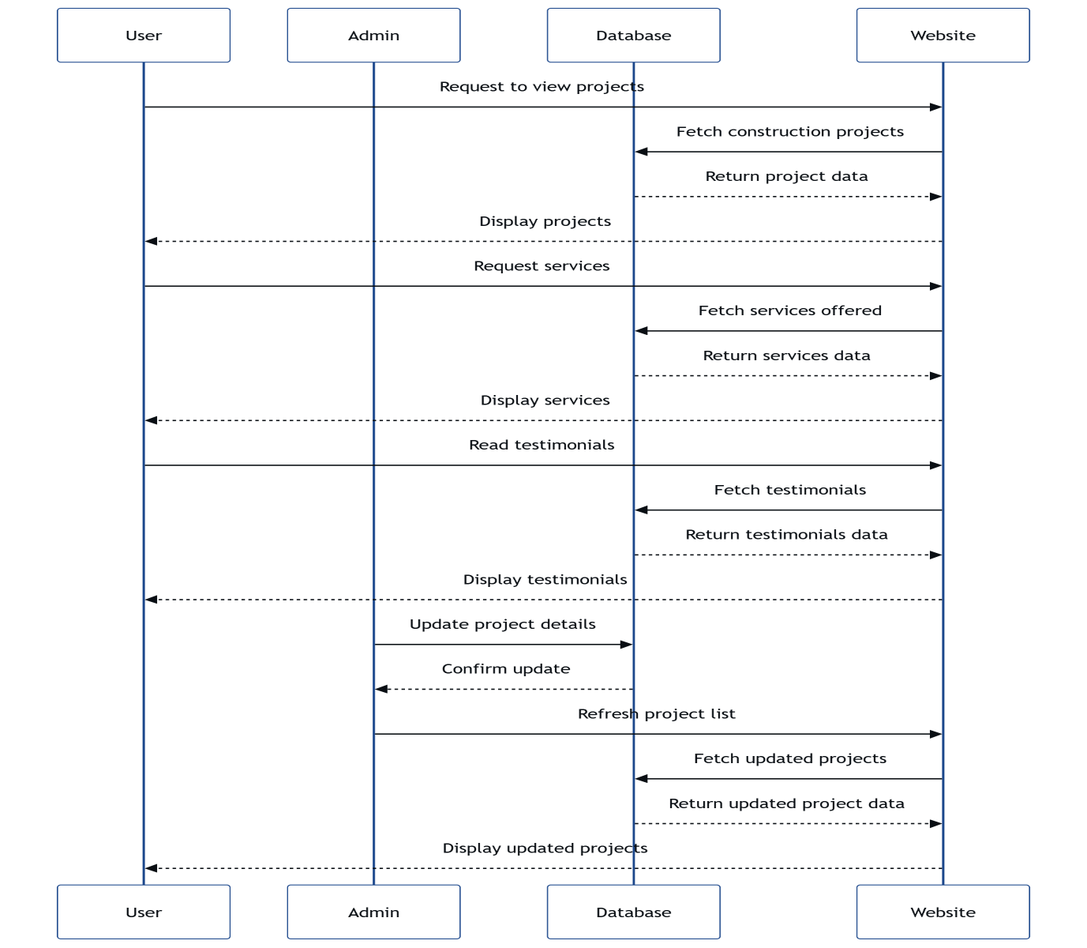

**Fig 4.4.2 UML Diagram**

**4.4.3 USE CASE DIAGRAM**

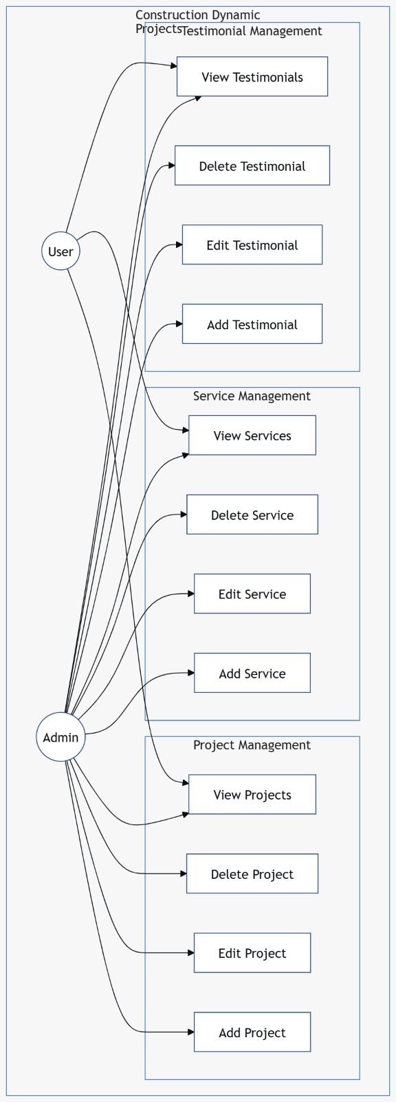

**Fig 4.4.3 Use Case Diagram**

**4.4.4 CLASS DIAGRAM**

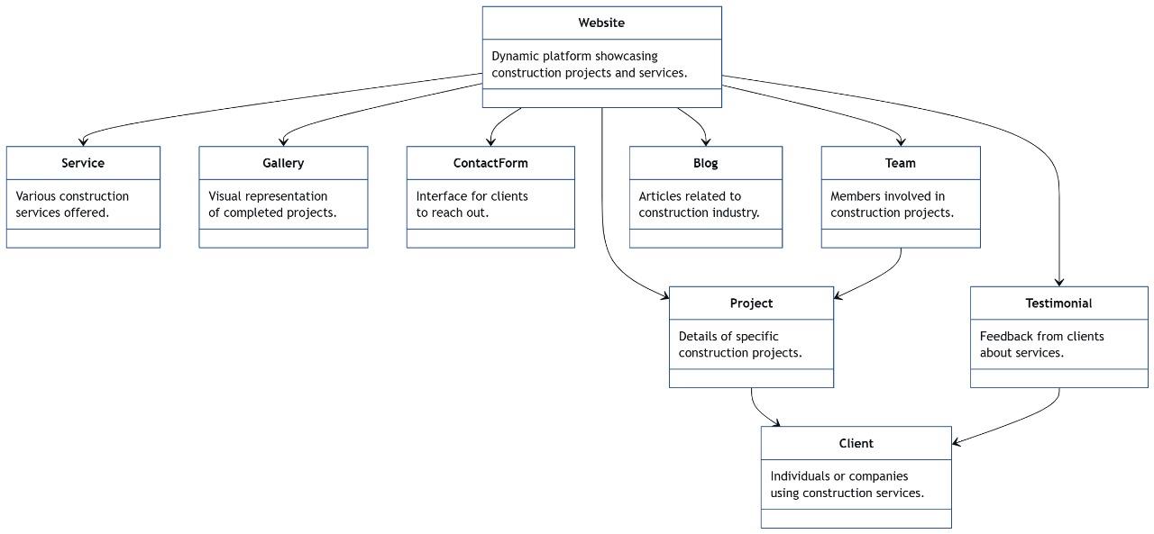

**Fig 4.4.4 Class Diagram**

**4.4.5 SEQUENCE DIAGRAM**

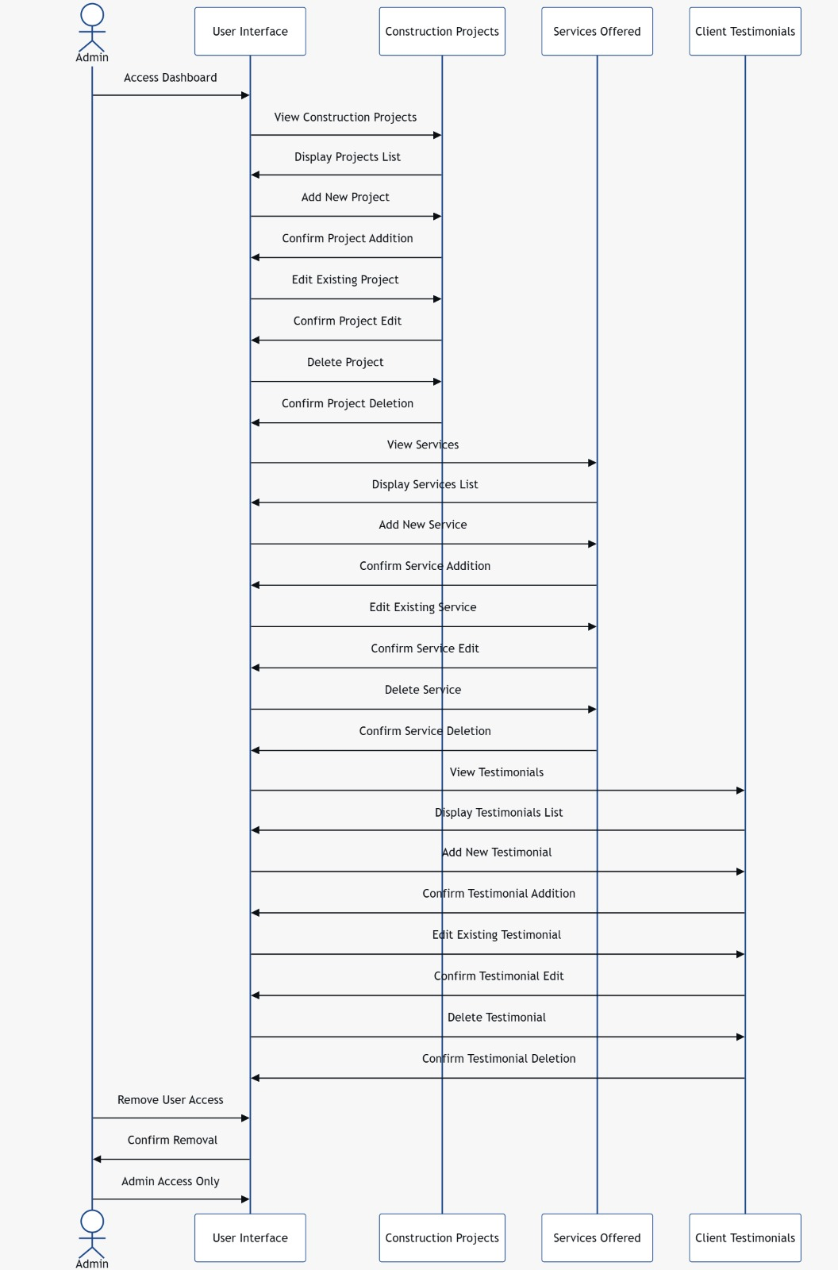

**Fig 4.4.5 Sequence Diagram**

**4.4.6 ACTIVITY DIAGRAM**

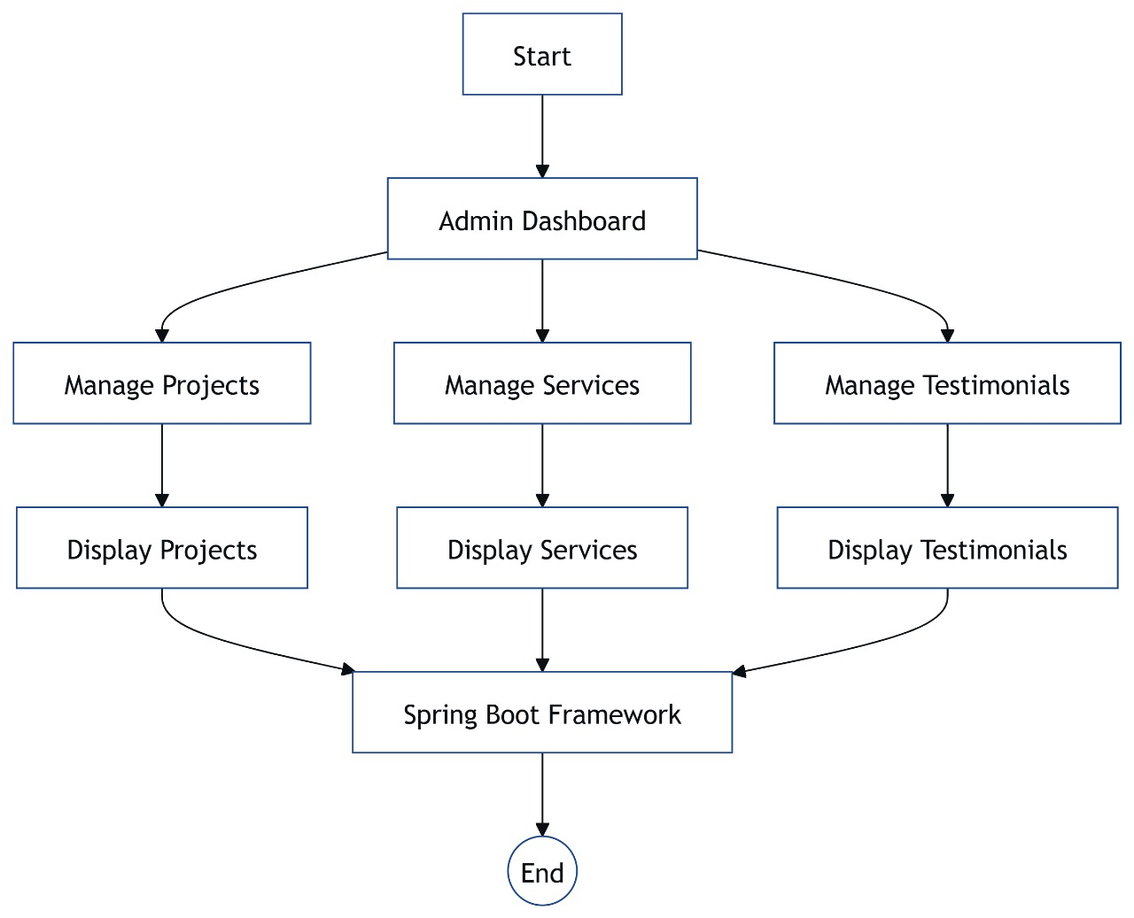

**Fig 4.4.6 Activity Diagram**

**4.5 IMPLEMENTATION**

**4.5.1 MODULES**

**1. Authentication Module**

* Admin Login
* Admin dashboard login
* Spring Security for role management

**2. Project Module**

* Add/update/delete construction projects
* Project details (title, location, images, status)
* Categorize by type (residential, commercial, etc.)
* Display projects dynamically on website

**3. Services Module**

* Add/edit/delete services (e.g., Architecture, Renovation)
* Include service icons/images
* Service descriptions with SEO-friendly content
* Display on home/about/services page

**4. Team Module**

* Name, position, social links, bio, photo
* Dynamic team section on “Our Team” page

**5. Testimonials Module**

* Client feedback/testimonials
* Name, project, rating, comments
* Optional approval by admin
* Carousel display on homepage

**6. Blog Module**

* Add/edit/delete blog posts
* Categories/tags
* Blog thumbnails, rich text content
* Comment system (optional with moderation)
* SEO meta title/description

**7. Contact Module**

* Contact form (name, email, message)
* Backend handling with DB storage
* Google Maps integration (optional)
* Admin view of messages

**8. About & Home Module**

* Dynamic content blocks for home/about us
* Change homepage headlines, intro sections, banners
* Carousel/banner management

**9. Admin Panel (CMS)**

* Central place to manage all above modules
* Rich text editor for projects/services/testimonials
* Image upload with preview
* Role-based control (admin/editor)

**10. Frontend with Thymeleaf**

* Dynamic rendering of all content
* Tailwind CSS or Bootstrap for styling
* SEO-friendly routes and layout fragments (header, footer, etc.)

**4.6 SCREENSHOTS**

**● Home Page**

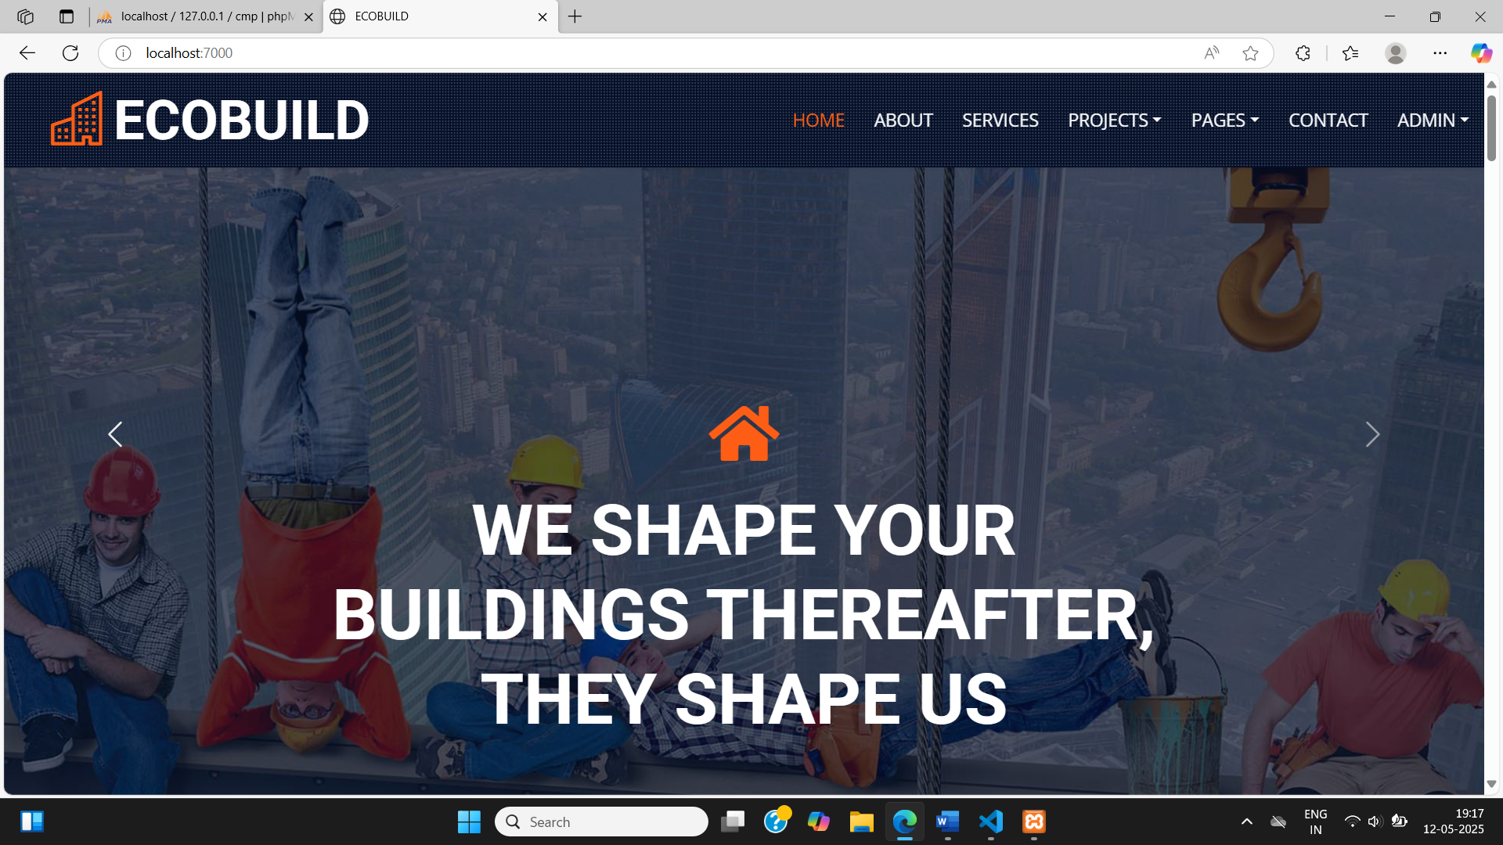

**● About us**

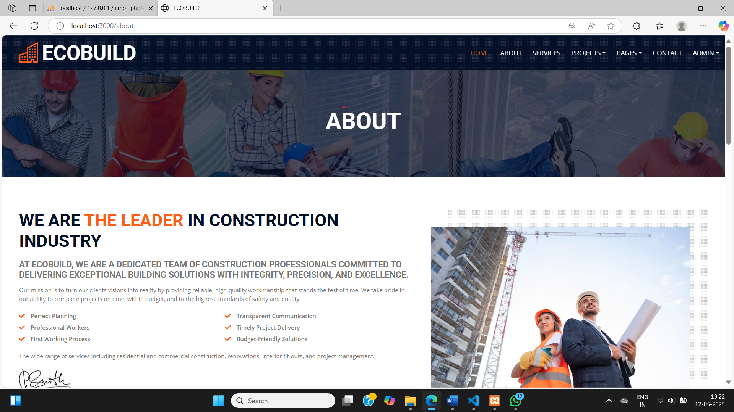

**● Services**

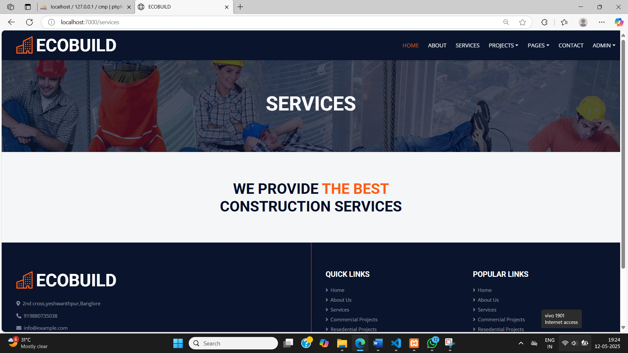

**● Projects**

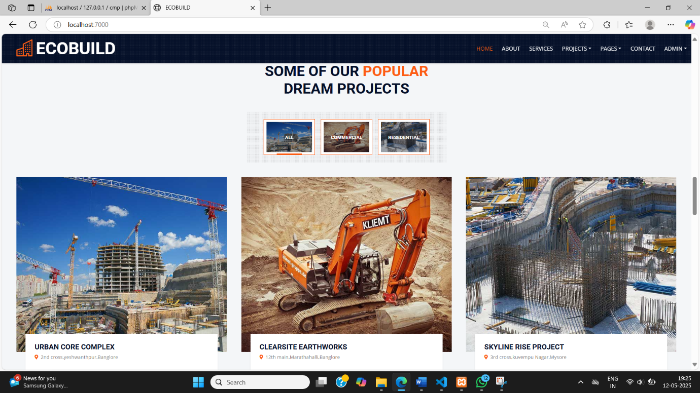

**● Testimonials**

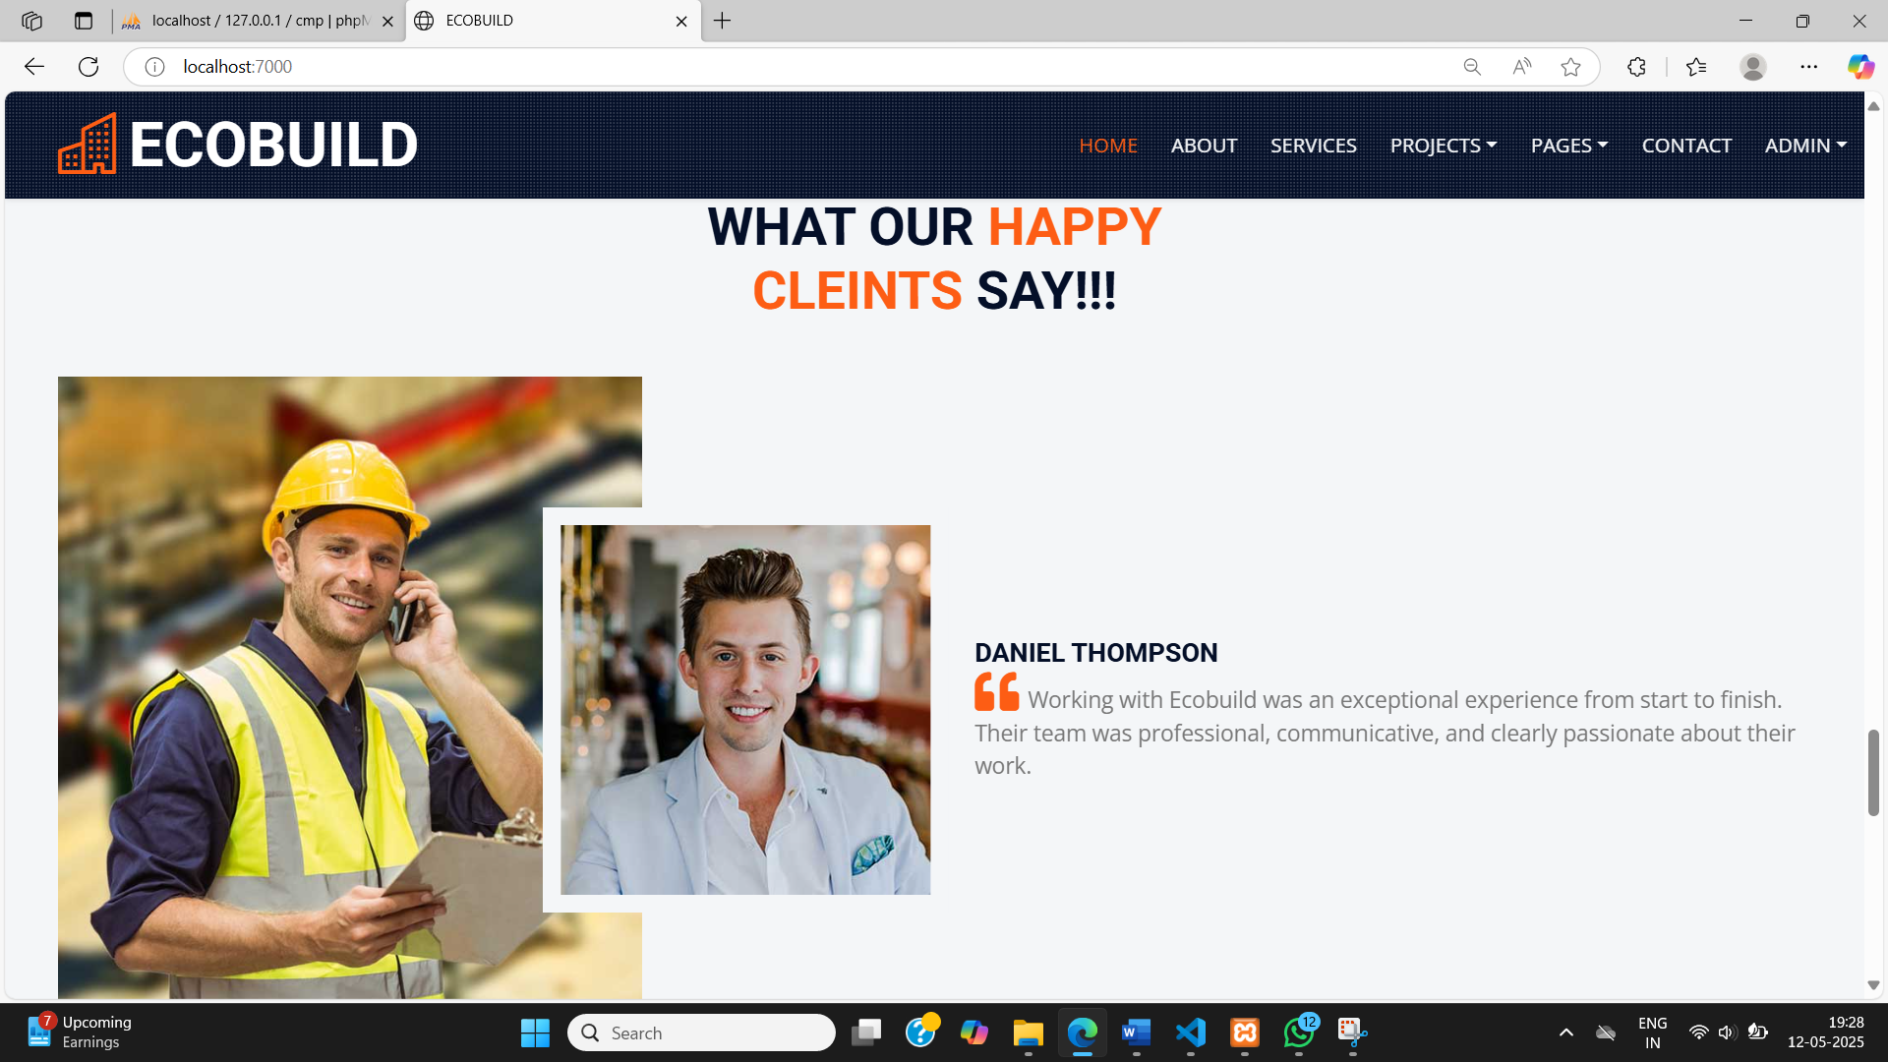

**● Contact us**

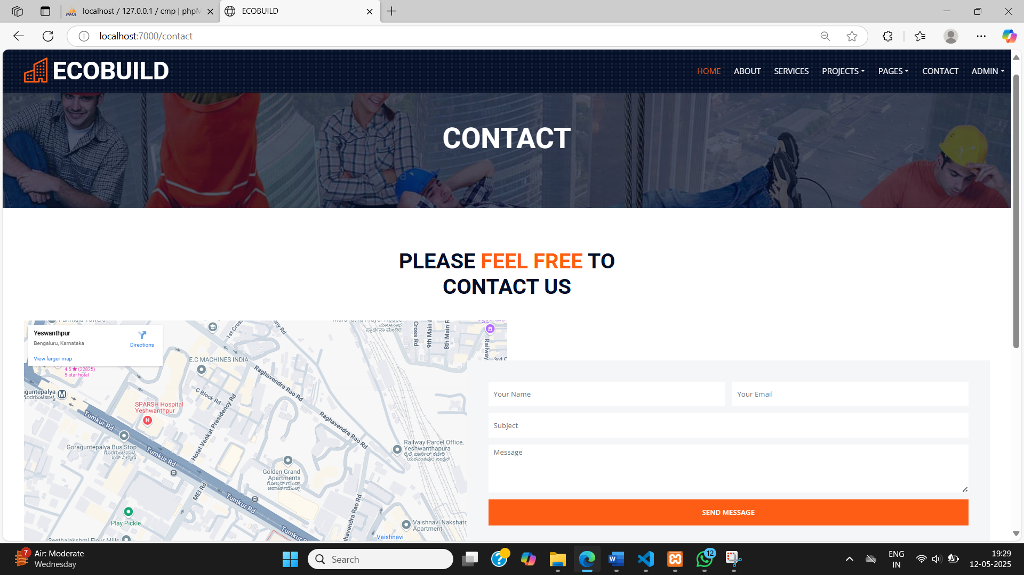

**● Database**

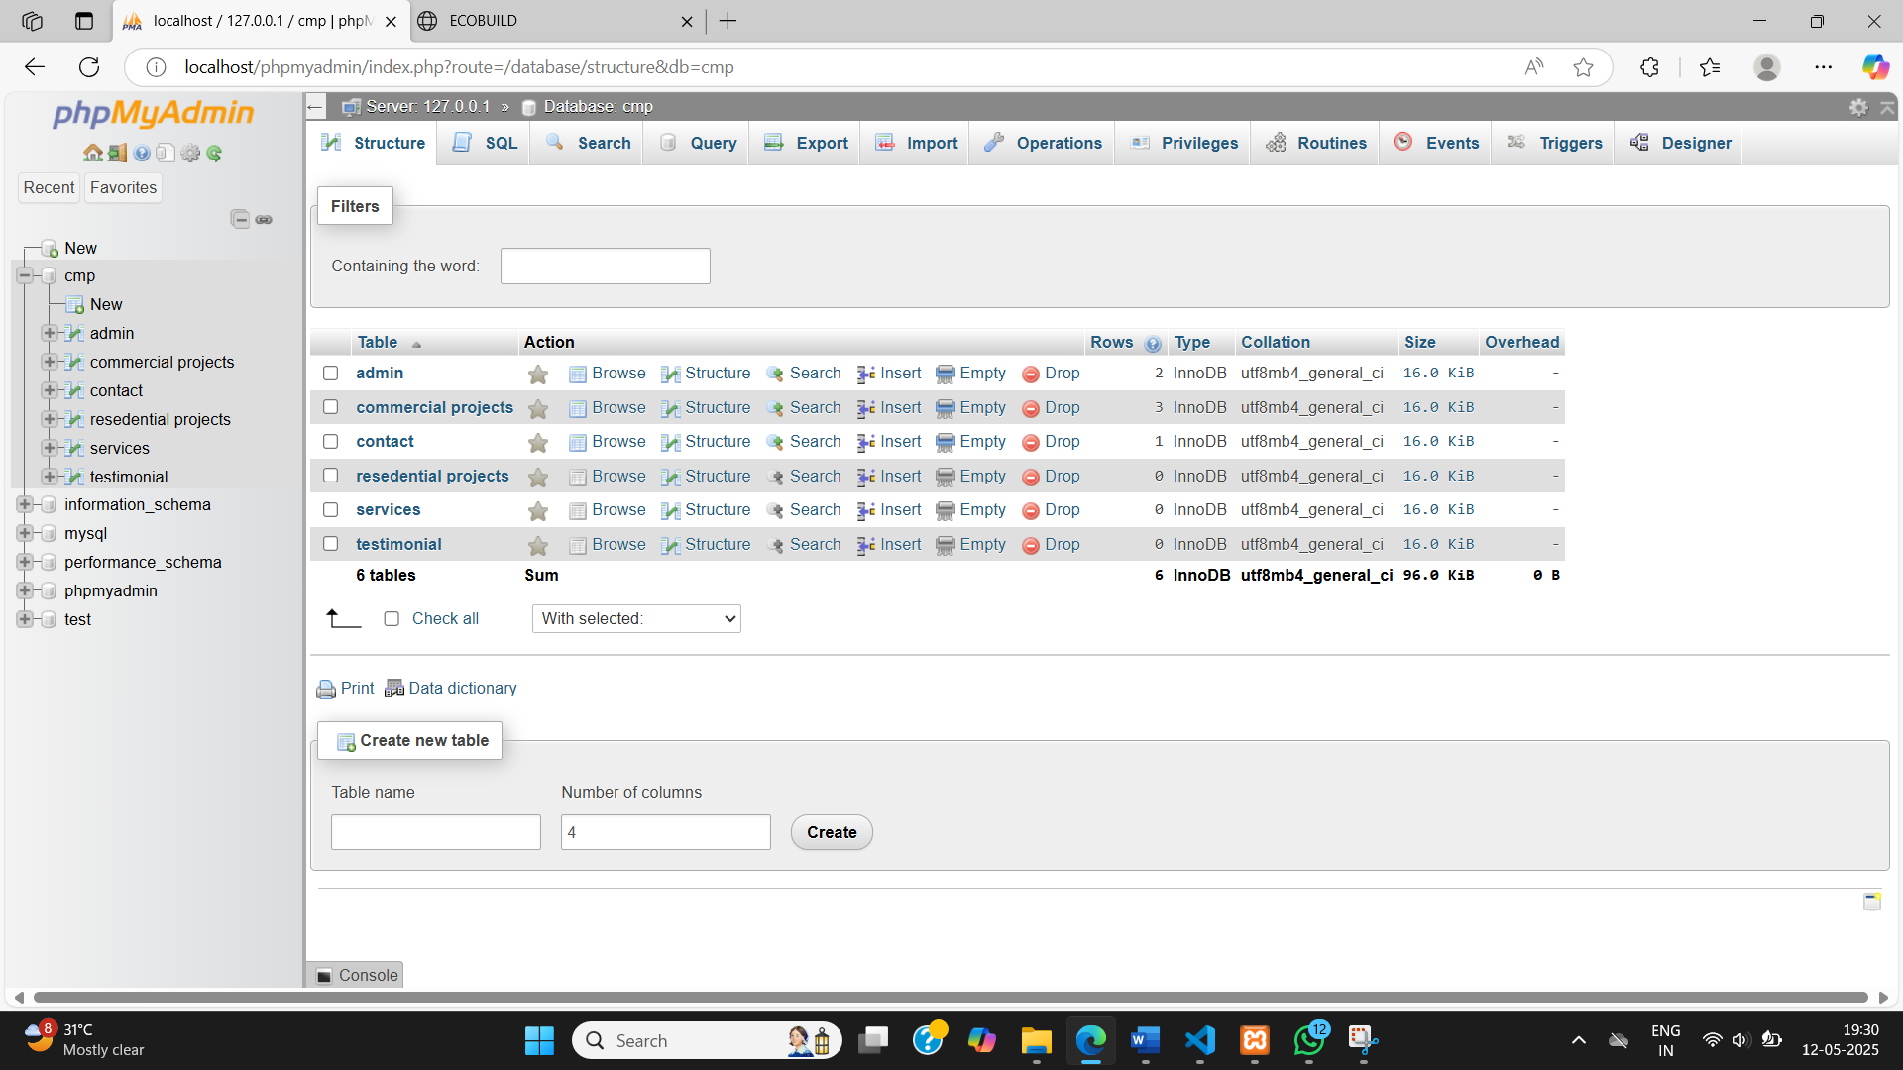

**● Admin**

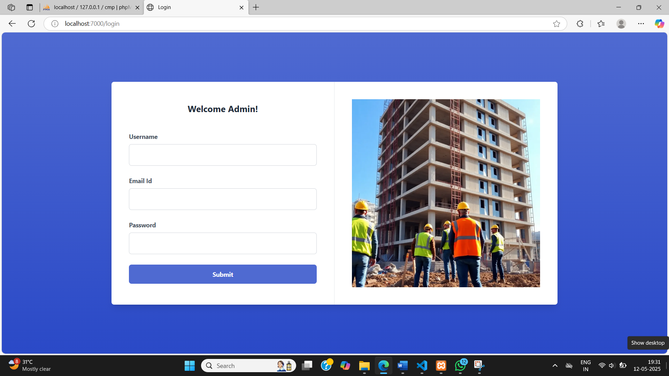

**● Admin Dashboard**

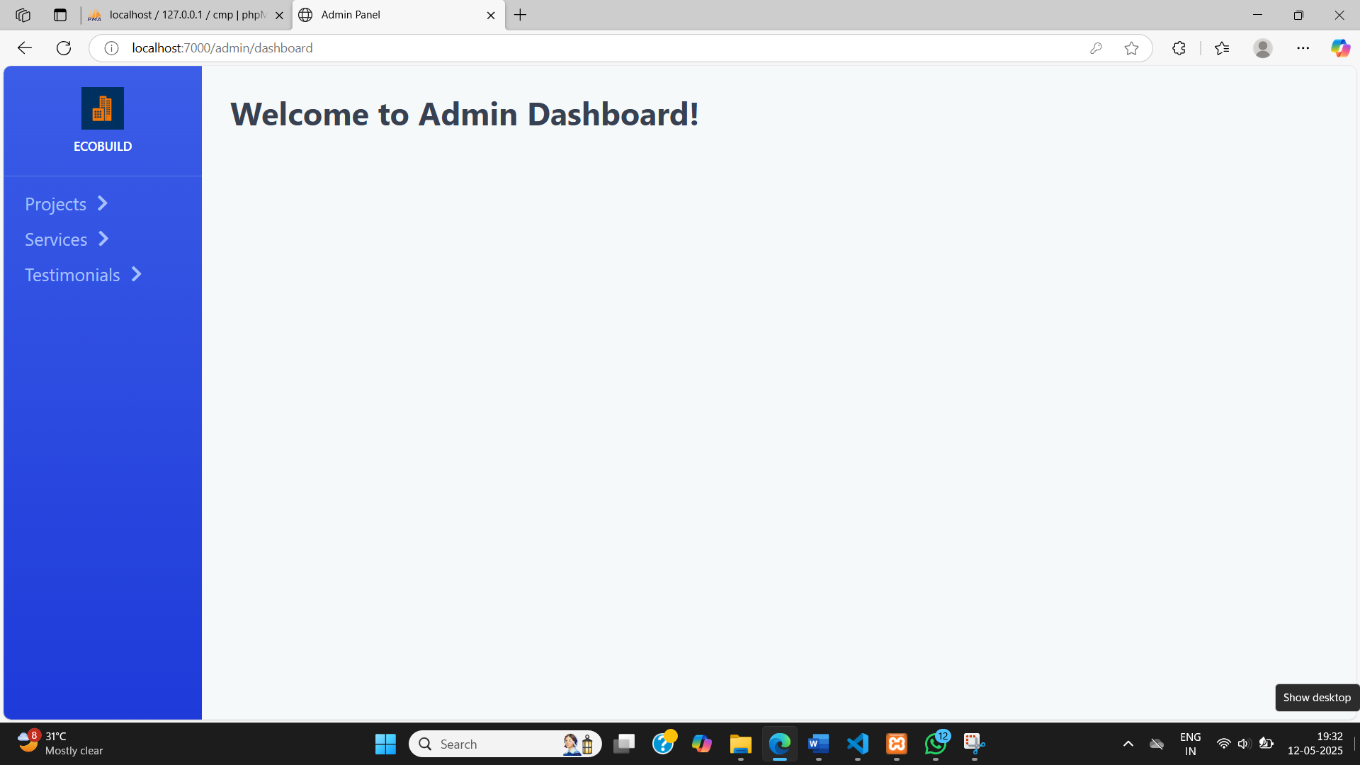

**● Add Projects**

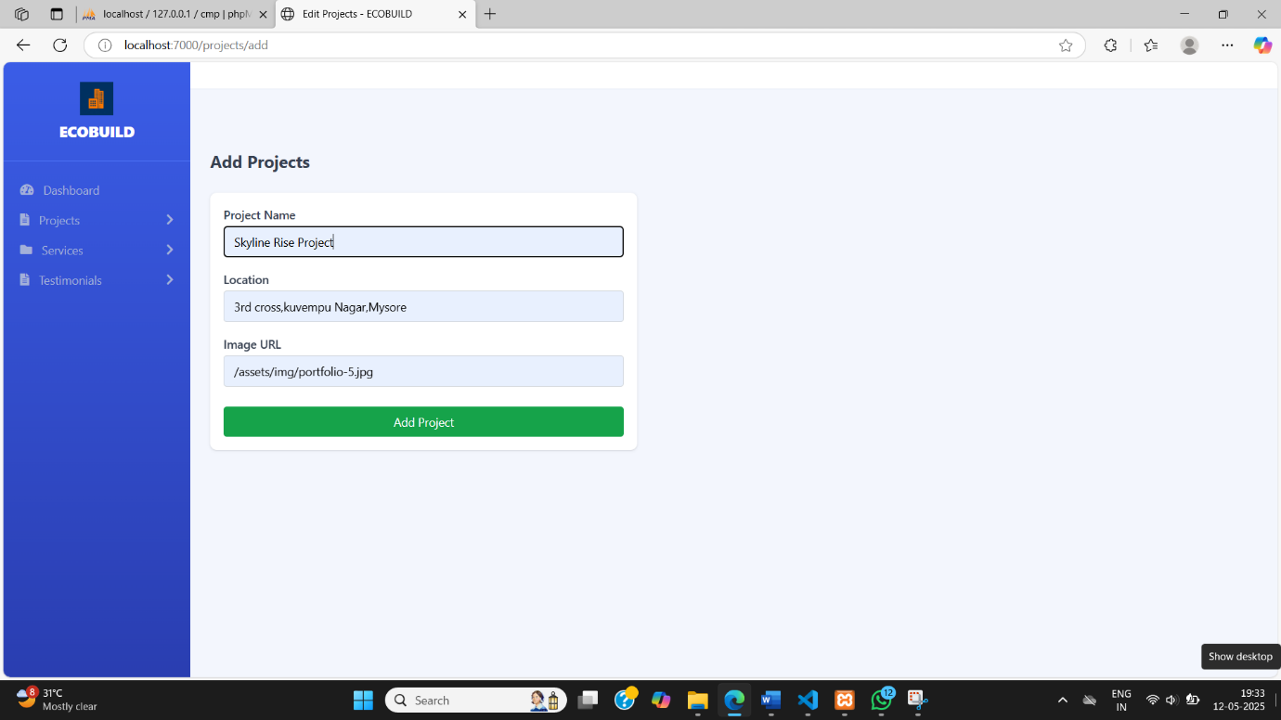

**● Edit Projects**

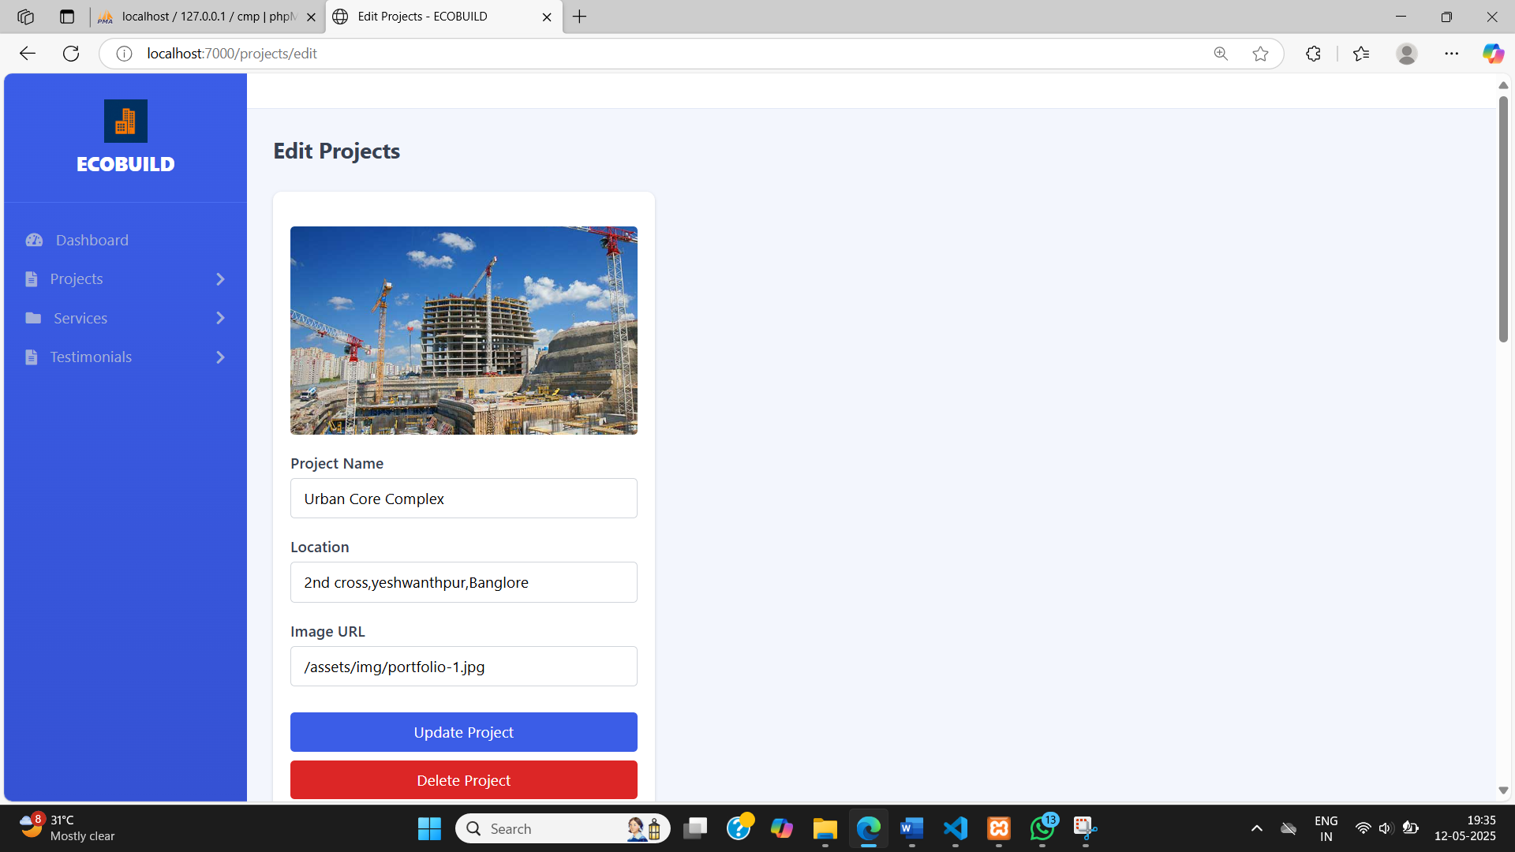

**● Data stored in MySQL**

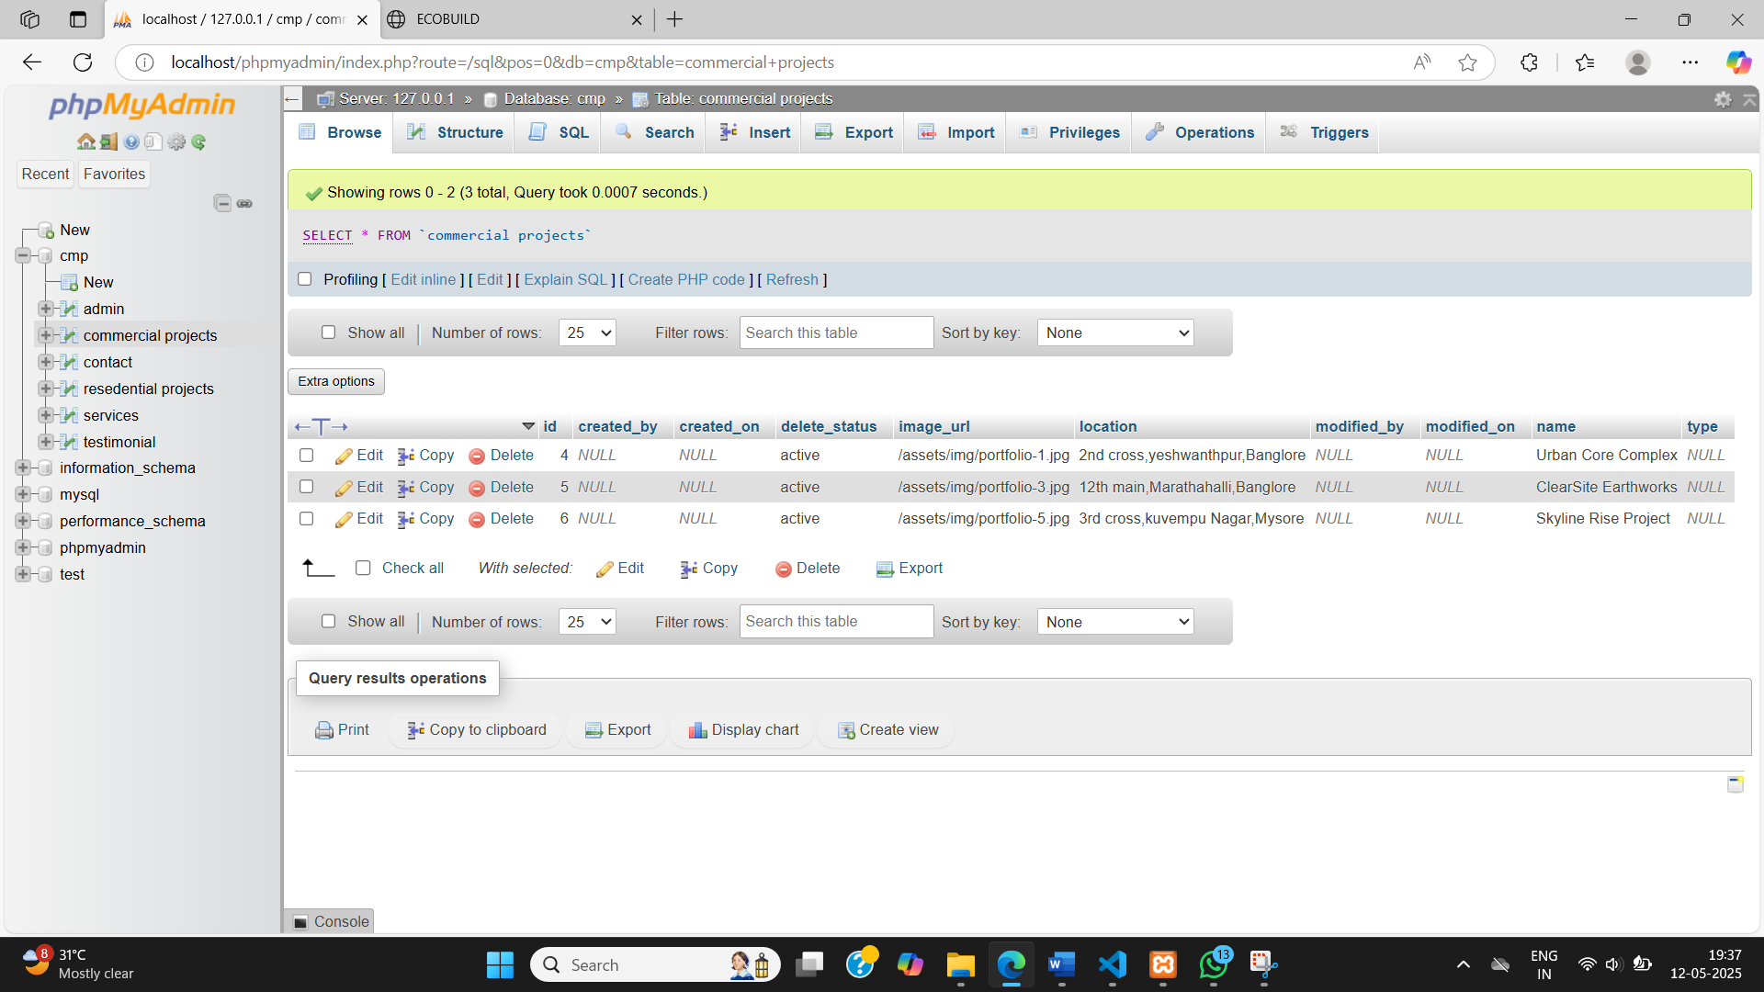

**CHAPTER 5**

**CONCLUSION**

A Construction Dynamic Project enhances efficiency, adaptability, and real-time monitoring within the construction industry by leveraging advanced technologies. Utilizing frameworks like Spring Boot, it enables seamless data management, automates workflows, and optimizes resource allocation, ensuring better coordination among stakeholders. The system fosters improved decision-making through structured data analysis, allowing project managers to track progress, manage materials, and allocate workforce effectively. With scalability and flexibility at its core, the project adapts to evolving construction demands, making operations more transparent and collaborative. Ultimately, this initiative modernizes construction management, reducing delays, minimizing costs, and enhancing overall productivity, contributing to a more efficient and sustainable approach to project execution. In dynamic construction projects, adaptability and responsiveness to unforeseen challenges are key to success. The conclusion emphasizes the importance of continuous monitoring, prompt decision-making, and a flexible project management system that can accommodate changes throughout the construction period. Successful completion requires not only technical expertise but also strong organizational communication, especially in the temporary nature of construction project teams. By embracing a dynamic approach, projects can navigate complexities, optimize resource allocation, and ultimately achieve their goals more effectively.

**BIBLIOGRAPHY**

For a Construction Dynamic Project utilizing Spring Boot, the bibliography would typically include references to key software development resources, construction management studies, and industry best practices. Foundational books on Spring Boot and microservice architectures, such as Spring Boot in Action by Craig Walls and Microservices Patterns by Chris Richardson, provide valuable insights into building scalable systems for dynamic projects. Research papers on construction automation and data-driven project management, published in journals like the Journal of Construction Engineering and Management, offer practical strategies for integrating technology into construction workflows. Additionally, documentation from Spring Boot, Hibernate, and REST API architecture serves as a technical reference for developers designing project management systems. Industry reports from organizations such as the Construction Industry Institute (CII) or the National Institute of Building Sciences also contribute real-world applications of digital transformation in construction.

**APPENDIX**

The appendix of a Construction Dynamic Project using Spring Boot serves as a reference for technical implementation, system architecture, and methodologies applied throughout the development process. This section includes documentation on Spring Boot dependencies, database schema design, API specifications, and deployment configurations. It highlights key technologies such as Spring Data JPA for managing project-related data, Spring Security for access control, and RESTful APIs for seamless communication between modules. Additionally, it outlines the workflow automation mechanisms, including job scheduling with Quartz, real-time updates through Web Sockets, and cloud integration for scalable infrastructure. The appendix also presents test cases validating various system functionalities, ensuring robustness in handling dynamic construction operations. By providing a structured reference to the project's technical components, this section enables developers and stakeholders to understand its architecture, facilitating future enhancements and optimizations.